Documentation

Introduction

The Star Wars API Wrapper interfaces with SWAPI (Star Wars API). This documentation will highlight the resources made available by this API Wrapper and will show you how to consume the resources with HTTP requests.

Getting Started

There are available API requests that can be made to the Star Wars API Wrapper and we will run through them in this documentation.

To get started, open a web browser to make an API request for a resource. In the first example, we are trying to get a list of Star Wars films:

<https://starwarsapiwrapper.azurewebsites.net/films>

The response is as follows:

["Episode 4: A New Hope","Episode 5: The Empire Strikes Back","Episode 6: Return of the Jedi","Episode 1: The Phantom Menace","Episode 2: Attack of the Clones","Episode 3: Revenge of the Sith"]

Next, we will try to retrieve a list of characters in film 1:

<https://starwarsapiwrapper.azurewebsites.net/films/1/characters>

The response is as follows:

["Luke Skywalker","C-3PO","R2-D2","Darth Vader","Leia Organa","Owen Lars","Beru Whitesun lars","R5-D4","Biggs Darklighter","Obi-Wan Kenobi","Wilhuff Tarkin","Chewbacca","Han Solo","Greedo","Jabba Desilijic Tiure","Wedge Antilles","Jek Tono Porkins","Raymus Antilles"]

Lastly, we will try to retrieve a list of starships in film 4:

<https://starwarsapiwrapper.azurewebsites.net/films/4/starships>

The response is as follows:

["Republic Cruiser","Droid control ship","Naboo fighter","Naboo Royal Starship","Scimitar"]

Alternatively, make use of the base URL to access all available resources within the API. Base URL: <https://starwarsapiwrapper.azurewebsites.net/>

An example of how to use the base URL to retrieve a list of starships in film 4 will be shown below:

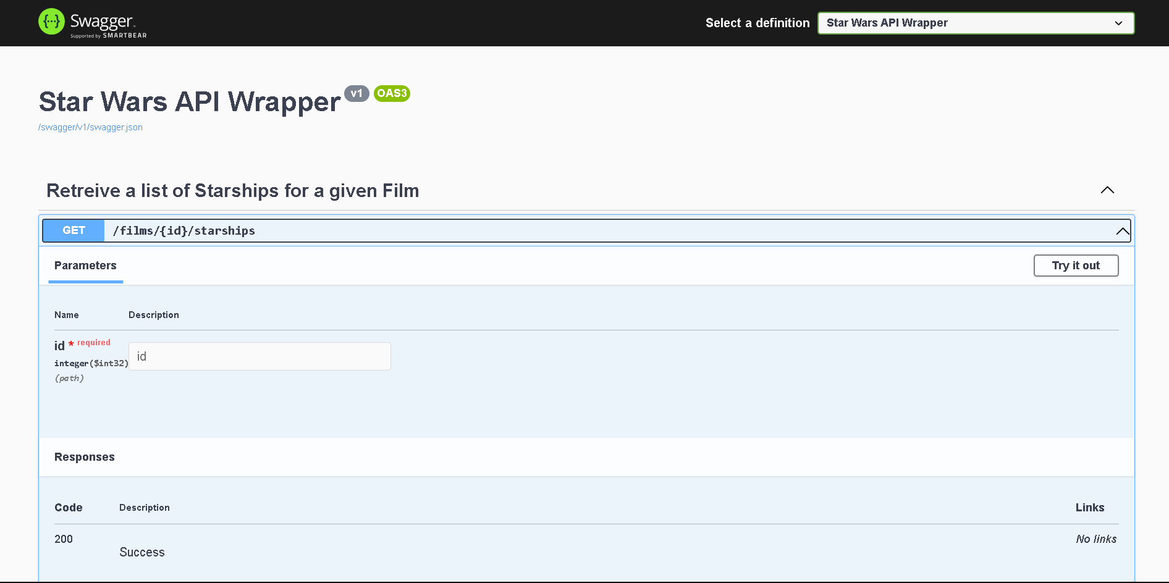

1

2

1. Click on GET /films/{id}/starships
2. Click on Try it out

4

3

1. Insert the id of the film for which you would like to retrieve a list of starships.
2. Click on Execute

The response is as follows:

